Powertrain Research
By MD Affan Mahdeen Haque

Title: Understanding Powertrain Mechanisms in RC Cars

This research report dives into the topic Powertrain in RC cars and their role, mainly focusing on the Driveshaft in RC cars and their functionality. This is an overview of drive shafts, their operational principles, and explains how they effectively transfer throttle inputs from the remote control into motion.

The Driveshaft 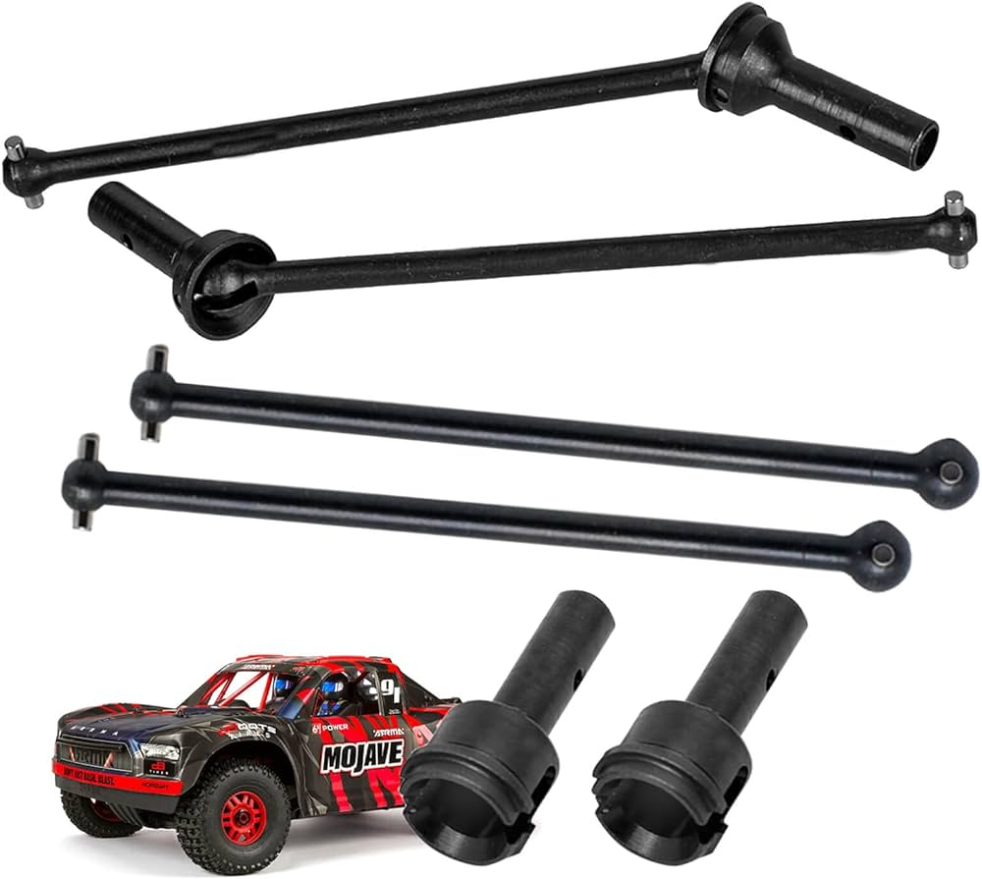
A drive shaft is a component for transmitting mechanical power, torque, and rotation, usually used to connect other components of a drivetrain that cannot be connected directly because of distance or the need to allow for relative movement between them. As torque carriers, drive shafts are subject to torsion and shear stress, equivalent to the difference between the input torque and the load. They must therefore be strong enough to bear the stress, while avoiding too much additional weight as that would in turn increase their inertia. (Admin1, 2023)
CVD (constant-velocity drive)
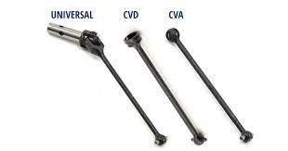
There are two main types of driveshafts used in RC racing cars - constant-velocity drive (CVD or CVA), and universal joints. The effectiveness of the driveshaft will depend on the driving conditions.
A CV shaft is a type of driveshaft that has two CV joints on either end. CV stands for Constant Velocity. Constant Velocity Joints transfer torque from the gearbox to the wheels at a constant speed. CV Joints allow a vehicle to maintain speed while turning at a wider range of angles without causing an increase in friction.
The main difference between the two is speed of rotation and friction. A brief comparison between these two types of driveshafts are given below.

Universal joints
- More forgiving handling
- In front: more responsive steering
- In rear: handles bump more smoothly
- Ideal for low grip, bumpy, technical tracks

CVDs/CVAs
- More responsive handling
- In rear: more stable in acceleration
- Ideal for high grip, smooth, open tracks
- Require more maintenance

The use of Universal drive shafts makes the car smoother and easier to drive. However, the universal drive shafts do not have the same shaft speed at the input and the output. Indeed, if the shaft is aligned the wheel will turn at the same speed as the differential outdrive
The CVD shafts tend to have higher friction and that heavily impacts the suspension of the car. As The angle of CVDs are not parallel to the chassis it results in more friction in the outdrive and the joints. Because the shafts being aligned it tends to push the wheel to the ground more causing more friction. (Admin1, 2023)

The advantages of having a CVD in the front and rear is described below.

In the front:
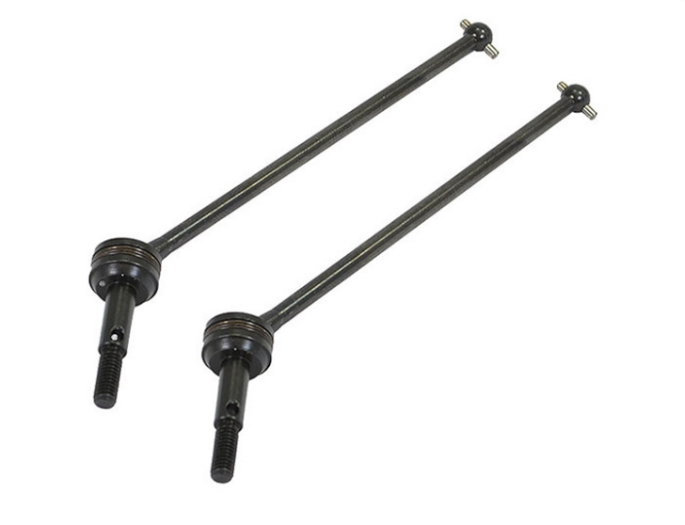Figure: Front CVD
The use of this option in the front gives a more responsive car with a more reactive feel. The traction in the front is increased and the car will have more steering.

In the back:

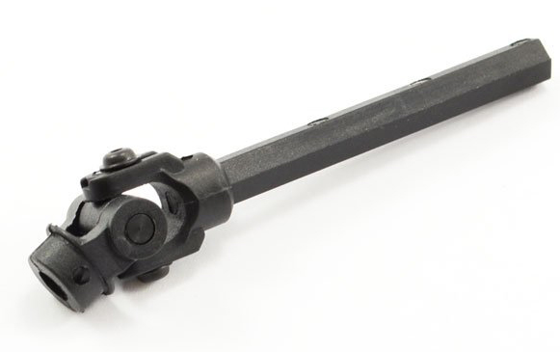 Figure: Rear central CVD
At the rear, this is where the use of CVD shafts on the car will have the most impact.
Indeed, the other important point of a CVD type shaft is that at high speed, it will tend to align itself. The suspension never being flat, in up or down travel, the driveshaft forming an angle will apply a force on the suspension. The car will be stiffer and will be more likely to stay flat under acceleration.
However, in fully up travel (after a jump for example), if the car accelerates, this force will push the wheel towards the ground, and stiffen the suspension. As a result, the car will therefore lose less speed.
The main drawback of this solution is that by stiffening the suspension, you will also prevent the suspension from doing its job properly, and it will not absorb the bumps of the track as well

Operational Principles:

Driveshafts deliver torque (the engine's rotational force) from the gearbox to the wheels. Driveshafts are often seen on RWD and 4WD cars. When the throttle is engaged on the remote control, electrical signals are transmitted to the electronic speed controller (ESC), which regulates the power supplied to the motor. The motor then converts electrical energy into rotational motion. which is transmitted through the drive shafts to the differential or gearbox. The rotational motion produced by the motor is transmitted through the drive shafts. These shafts serve as mechanical links between the motor and the differential or gearbox. The rotational motion from the drive shafts enters either the differential or gearbox, depending on the specific design of the RC car. These components help manage the distribution of power to the wheels, allowing for differential speeds when turning. As the wheels rotate, they create traction with the ground, which propels the RC car forward or backward, depending on the direction of rotation and the throttle input.

Bibliography
Admin1. (2023, April 25). The Basics on Driveshafts and How Does a Drive Shaft Work. Retrieved from Reel Driveline.com: https://reeldriveline.com/articles/the-basics-on-driveshafts-and-how-does-a-drive-shaft-work/

